USA Test Prep Assignment for Circles Remediation Due: Monday November 4th
I have created some extra practice with videos embedded to help you remediate the circles standards. These assignments are optional but keep in mind you are expected to still understand these standards as we have an EOC in this course. The assignments are in a group titled “Circles Remediation Assignment” and will be available to you once you have joined the class. You can complete the activities in any order you would like. In order to gain credit back on your Circles Test, you must complete the Assignment and then take the “Circles Remediation Test”. The score you earn on the test will be averaged with your current Circles Test score and will be entered into the gradebook.

In order to access the assignments in USA Test Prep you will need to follow the instructions below:
- Log in to USA Test Prep (if you don’t have an account, then create one using “kell” and “newton77”)
- Choose “Join Class” from under your name along the left side of the screen
- Choose “Ryan Dearing” from the teachers and then “Geometry Fall 2019” under my classes
  - A pop up box will appear and ask you if you want to add assignments, you MUST CLICK to add assignments!
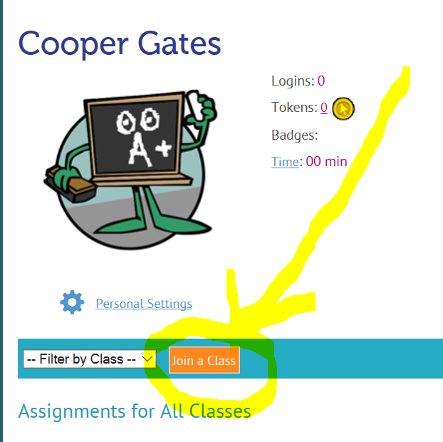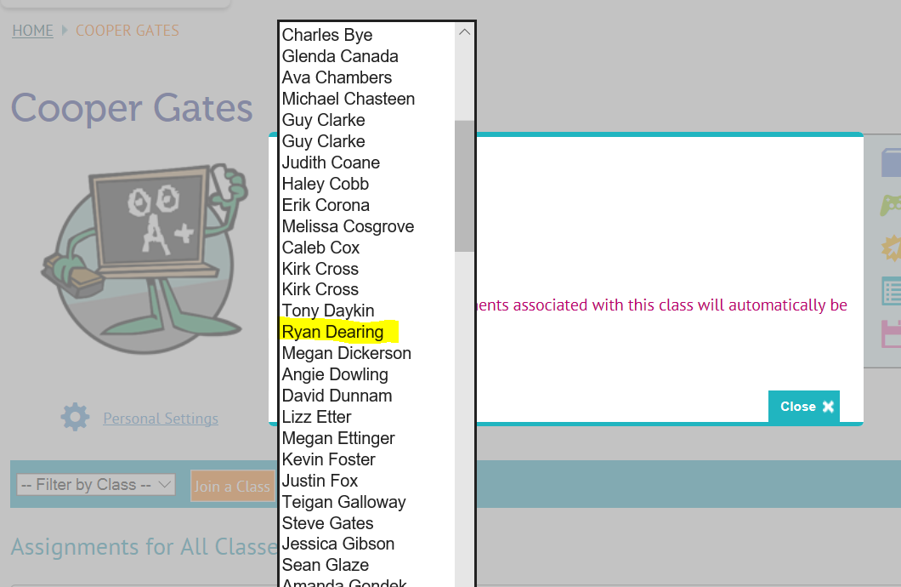

If needed, you can type in the following code to take the remediation test:
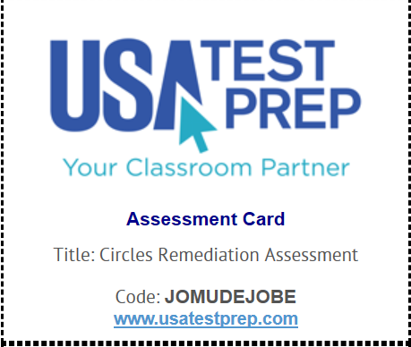

It is highly recommended and encouraged to do the assignments FIRST prior to attempting the Test.

