Task: Today you will be summarizing our unit about circles! You have 2 options of how you can do this.

- You can make a collage about circles on paper or on the computer

OR

- You can make a video/tik tok abut circles to share (tik tok/video MUST be school appropriate)

Directions:
Our task is to summarize what we have learned about circles. It must include the following:
• A picture of a circle with the following parts labeled: chord, diameter, radius, tangent, secant, center, minor arc, major arc
• The formulas used to calculate arc length, area of a sector, formulas used to find all 4 types of angles (interior, exterior, central, inscribed) and the formulas used to finding missing pieces when you have special segments (2 secants, 1 secant/1tangent, intersecting chords, 2 tangents)
• The general and standard form equation for a circle. Include how you know what the center is and the radius when you have general form.
• An explanation of how we can graph circles when we know either the general form or standard form
• Create five math problems using 5 different formulas of your choice from the formulas you had to list on your collage or video--you must work out the problems and show your work

Submissions:
If you complete a collage on paper, it must be legible and you will take a picture to submit. If you complete a collage on the computer, you must save it in a file to submit. If you create a tik tok, you will send that video to your teacher.

***In order to submit your work, you will need to use your 365 account email. See the page below if you need help getting in to 365***

Your work must be submitted to your teacher via Office 365. PLEASE MAKE SURE YOU CLICK ON THE LINK THAT IS LISTED NEXT TO YOUR TEACHER!

You will submit your work using the QR code or the link next to your teacher’s name:

For Mrs. Hill’s Class: https://forms.office.com/Pages/ResponsePage.aspx?id=-x3OL5-ROEmquMR_D8kYLWFupzXJzd5BjqXbDmUbVUtUMDNXNjNVVU81R05YWVBTV1NBTDBMSk5ITi4u

For Mrs. Pinson’s Class: https://forms.office.com/Pages/ResponsePage.aspx?id=-x3OL5-ROEmquMR_D8kYLbNVkIPEh6BPmtKs7g2wvElUMUMyMEdENDBCOFIzV0k4QldBU1JBRk5QUC4u

For Ms. Pusatere’s Class: https://forms.office.com/Pages/ResponsePage.aspx?id=-x3OL5-ROEmquMR_D8kYLd5AGj4WsHtMmv1GFM2Ko5dUOExBS0lDWVhEUFI1RVZSQ0FUSU44TE1SUC4u

Need help getting into office 365?
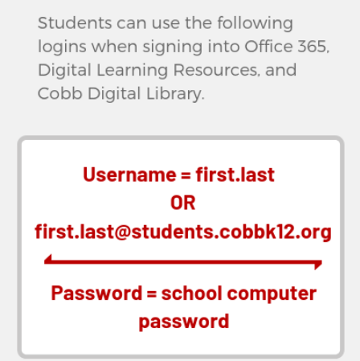
More help with office 365 can be found at this link: https://tinyurl.com/365LOGINHELP

