Unit 1 Transformations in the Coordinate Plane Extended Response NAME:___________________________
Draw the image of the figure after a reflection in the x-axis.
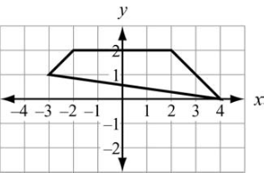

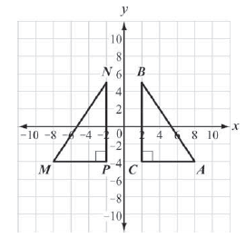
Unit 2 Similarity and Congruence Extended Response
Is ΔMPN congruent to ΔABC? Explain

__________________________________________________

__________________________________________________

__________________________________________________

__________________________________________________

__________________________________________________

__________________________________________________

__________________________________________________

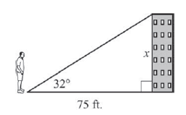
Unit 3 Right Triangle Trig Extended Response

Ricardo is standing 75 feet away from the base of a building.
The angle of elevation from the ground where Ricardo is standing
to the top of the building is 32°. Explain how Ricardo can find
the height of the building without measuring it. Use the information
in the table to give an answer.
__________________________________________________________________

__________________________________________________________________

__________________________________________________________________

__________________________________________________________________

__________________________________________________________________
Unit 4 Circles and Volume Extended Response
Billy is creating a circular garden divided into 8 equal sections. The
diameter of the garden is 12 feet. What is the area, in square feet, of one
section of the garden? Use π = 3.14. Explain how you determined your answer.
___________________________________________________________________________

___________________________________________________________________________

___________________________________________________________________________

___________________________________________________________________________

___________________________________________________________________________

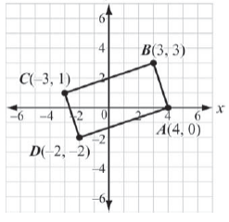
Unit 5 Modeling Geometry Extended Response
Prove that ABCD is a rectangle.

____________________________________________________

____________________________________________________

____________________________________________________

____________________________________________________

____________________________________________________

Unit 6 Probability Extended Response
Terry has a number cube with sides labeled 1 through 6. He rolls the number cube twice. What is the probability that the sum of the two rolls is a prime number, given that at least one of the rolls is a 3? Explain your process in solving the problem.

_____________________________________________________________________________________

_____________________________________________________________________________________

_____________________________________________________________________________________

_____________________________________________________________________________________

_____________________________________________________________________________________

_____________________________________________________________________________________

_____________________________________________________________________________________

