Geometry Student Name: _____________________________

Formative Assessment #1

Unit 4 -- Circles Date: _______________________ Block: ______

Matching: Using the diagram, match the notation with the term that best describes it.

|  |  |  |  |  |
| --- | --- | --- | --- | --- |
|  | 1. | tangent | **A.** | *C* |
|  | 2. | Point of Tangency | **B.** | *B* |
|  | 3. | Chord | **C.** |  |
|  | 4. | Diameter | **D.** |  |
|  | 5. | Secant | **E.** |  |
|  | 6. | Radius | **F.** |  |
|  |  |  | **G.** |  |
|  |  |  | **H.** |  |

**J.** 

7. Find the value for x.  8. Find the value of x.

 x = _______ x = ________

|  |  |
| --- | --- |
| 9. Find the value of *PQ* .  *PQ = _________* | 10. is tangent to circle O. Find  the radius of the circle.  r = ______ |

11. What would the measure of need to be 12.

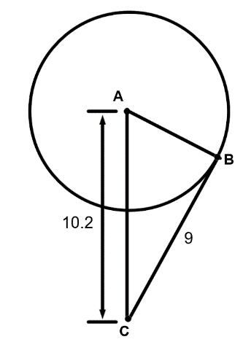 for  to be tangent to Circle A? Find the value of x.

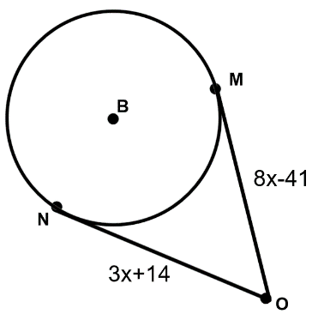

AB = _______ x = ______

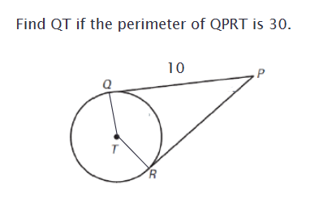

13.

QT = ________

**Multiple Choice** Choose the best answer.

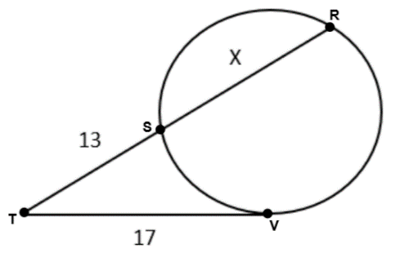______14. Find the value of *x* in the diagram to the right.

A. 11.9 B. 9.2

C. 24.6 D. 35.2

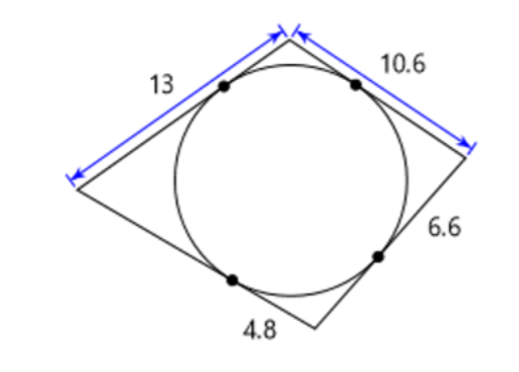

_______15. Find the perimeter of the figure to the right.

A. 48.8 B. 21

C. 62.1 D. 31.4

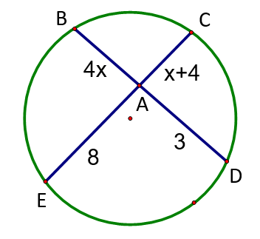16. Find the value of x and the length of  and :

x = ______ AB = ______ EC = _______

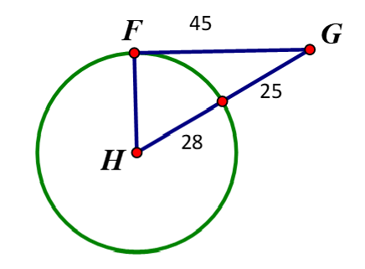17. Is FG tangent to ? Show work to justify your answer.

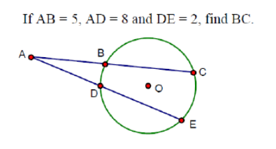

18. BC = __________

19. Use the picture below to find the value of x. Then, find the value y.

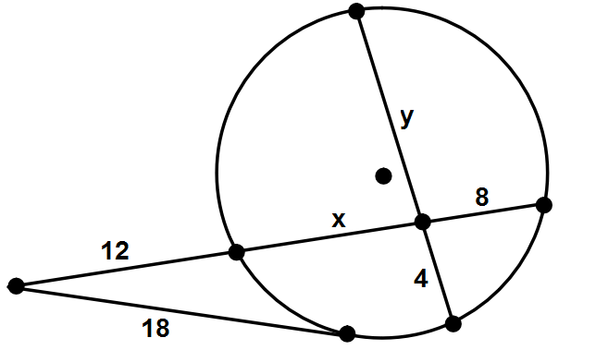

x = __________ y = __________