Geometry Student Name: _____________________________

Formative Assessment #2

Unit 4 -- Circles Date: _______________________ Block: ______

**\*\*\*\*ALL work must be shown for credit!!!\*\*\*\***

**Quiz 1 Revisited**



For #s 1 and 2, fill in the blank with one of the words below:

Tangent Semicircle Diameter

Radius Secant Chord

1.  is a _____________________.

2.  is a _____________________ .

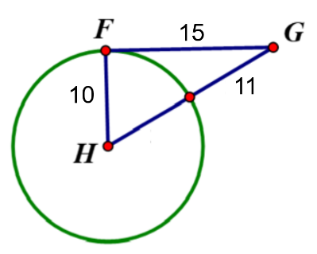

3. Use the image to the right, is segment FG tangent to Circle H? Justify answer with work and/or explanation.

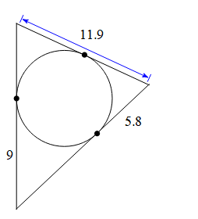4. Find the perimeter of the triangle.

Perimeter = ___________

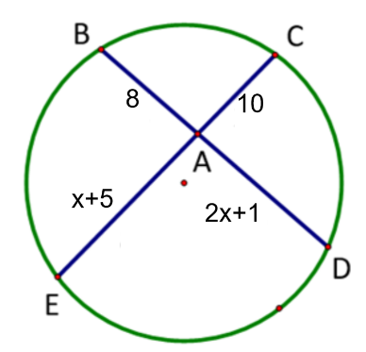5. Find the length of  6. If AB = 5, AD = 8 and DE =2, then find BC.

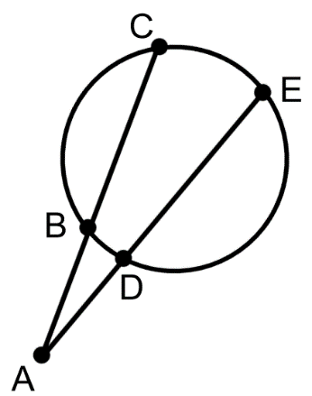

BD = ______ BC = _______

**I can use the relationship between central angles and their arcs to determine missing measures.**

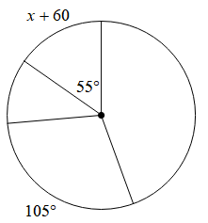

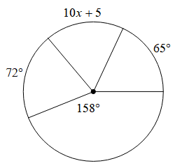7. Determine the value of x. 8. Determine the value of x.

x = ________ x = ________

9. and are diameters of the circle $⊙$ A. Find the measure of the indicated arcs.

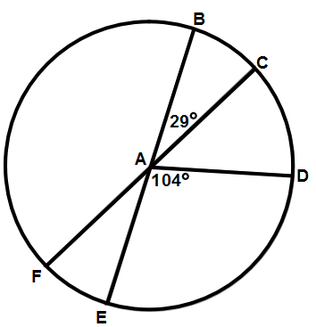

a. $m\hat{FE}$ = _________ b. $m\hat{CD}$ = _________

c. $m\hat{CFD}$ = ________ d. $m\hat{EBC}$ = ________

e. $m\hat{CE}$ = ________ f. $m\hat{BDF}$ = ________

**I can use the relationship between inscribed angles and their arcs to determine missing measures.**

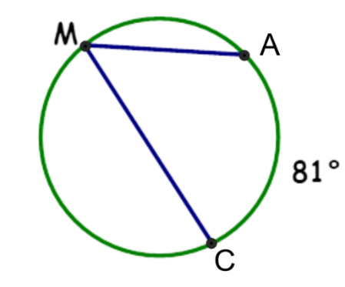10. Find the measure of . 11. Find the measure of .

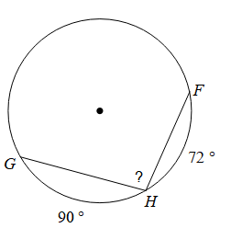

= _______ = _______

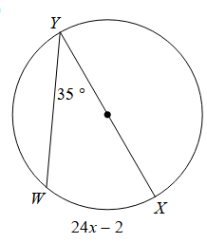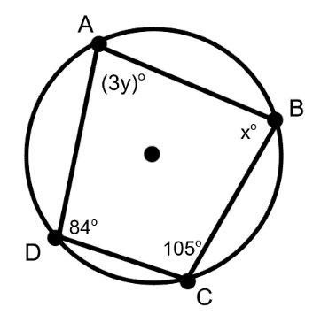12. Find the measure of x. 13. Find the value of x and y.

x = ______ x = ______

y = ______

**I can use the relationship between inside and outside angles and their arcs to determine missing measures.**

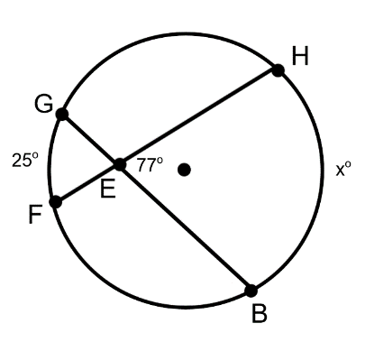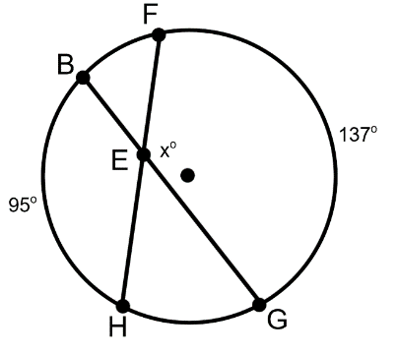14. Find the value of x. 15. Find the value of x.

x = _______ x = _______

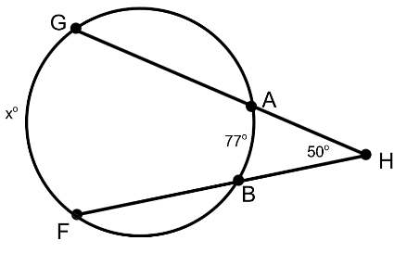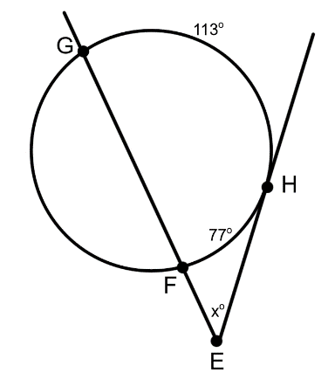16. Find the value of x. 17. Find the value of x.

x = ________ x = ________

**Mixed/Extension**

18. **is tangent to Circle *D* and . 19. Given that point B is the center of the circle,

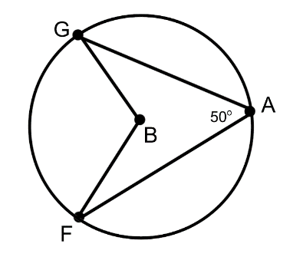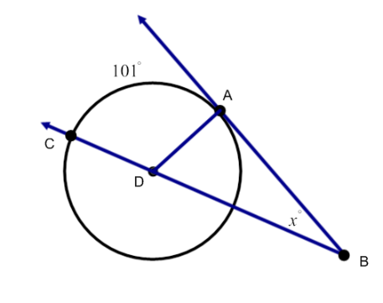 Find the value of x. Find the .

x = ______  = _______

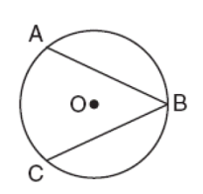20. In Circle O, . 21. Find the value of x.

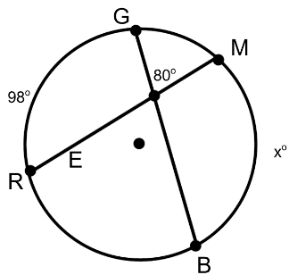 Find the .

 = _______ x = _______

22. Given that  is a tangent 23. Find the value of x.

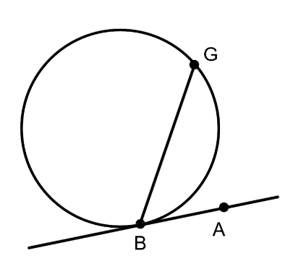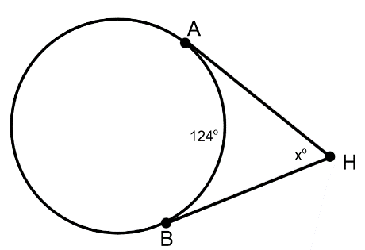 And , find the

.

 = ______ x = ______

24. In the circle below,  is a diameter. Determine the value of the following: x = ______

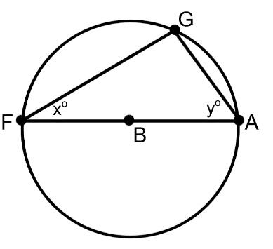

y = ______

 = ______

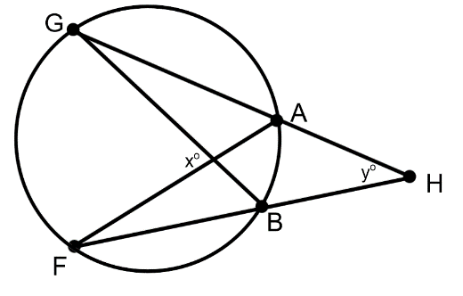25. If  and , find the value of x and y.

x = ______

y = ______

Student Name: _________________________________________

Work will still be checked, this sheet is for convenient grading. If correct work isn’t present on your test, you won’t receive credit.

Record all answers from quiz below:

1. _____________________ 2. _________________

3. ________ 4. ________ 5. ________ 6. ________

7. ________ 8. ________ 9a. ________ 9b. ________

9c. ________ 9d. ________ 9e. _________ 9f. _________

10. ________ 11. ________ 12. _________ 13. x = ______

y = ______

14. ________ 15. ________ 16. _________ 17. _________

18. ________ 19. ________ 20. _________ 21. __________

22. ________ 23. _________ 24. x = __________ 25. ___________

y = ___________

 = _______