Geometry Student Name ______________________________

Formative Assessment #2

Unit 4 – Circles Date: ______________________ Block: _______

SHOW ALL WORK FOR FULL CREDIT.

1. Identify each statement as true or false. *(1 mark each)*

a. The degree measure of an arc is equal to half the measure of its central angle. _____________

b. Two inscribed angles intercepting the same arc are congruent. _____________

2. Complete the conjecture:

The opposite angles of a quadrilateral inscribed in a circle are ____________________________.

3. Find the missing measure. 4. Find the measure of .

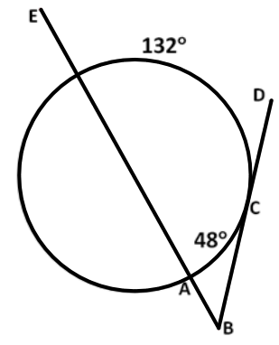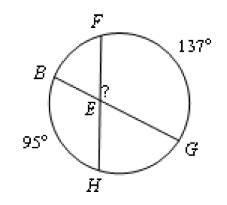

Missing measure = _________  = _________

5. Find the measure of .6. **is tangent to Circle *D* and .

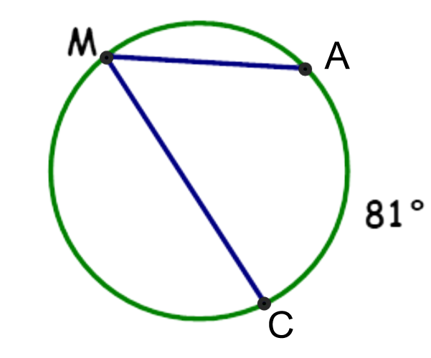 Find the value of x.

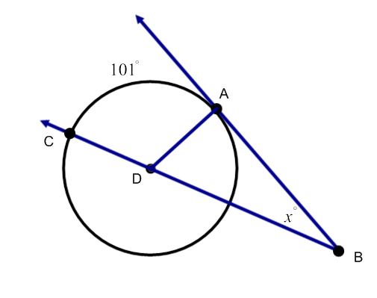

*= ________ x =* ______________

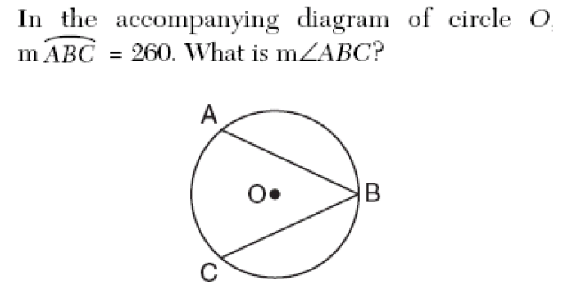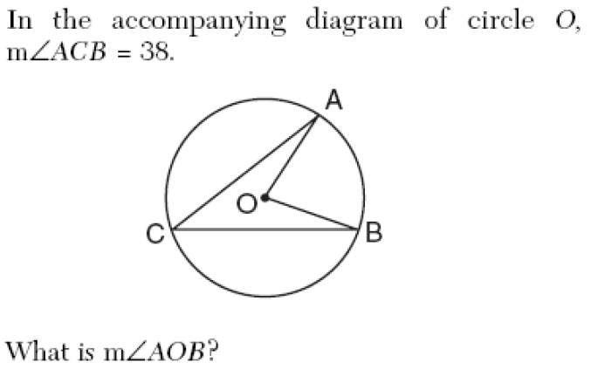7. 8.

 *= _________________ * **=** ___________

9. The circle below has the center marked. Determine the value of *e* and *f*.

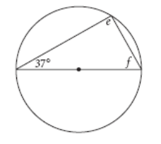

*e =* ________

*f =* ________

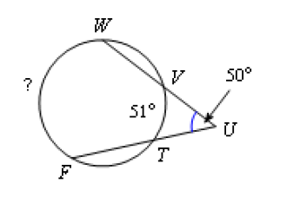

10. Find the missing measure.

Missing measure = _________

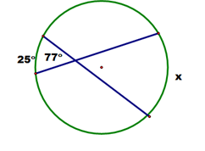11. Find the value of x.

x = ______

12. and are diameters of the circle $⊙$ A. Find the measure of the indicated arc.

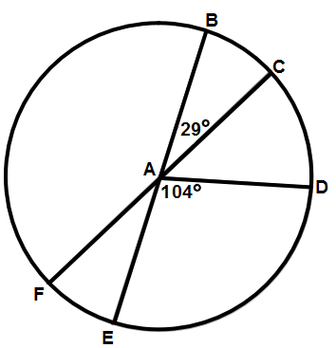

a. $m\hat{FE}$ = _________ b. $m\hat{CD}$ = _________

c. $m\hat{CFD}$ = ________ d. $m\hat{EBC}$ = ________

e. $m\hat{CE}$ = ________ e. $m\hat{BDF}$ = ________

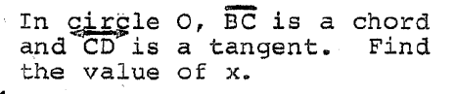

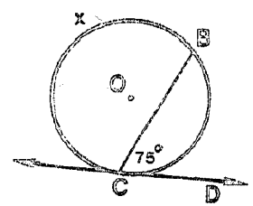13.

x = __________

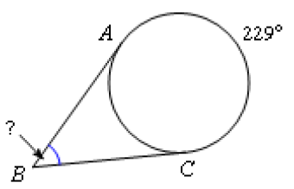14. Find the .

= ________

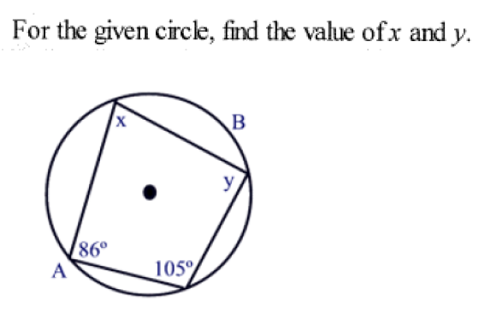

15.

x = _________ y = _________