Geometry Name ________________________

Formative Assessment: Similar Triangles Date ______________ Period _____

1. Determine if the two triangles are similar. If so, state the similarity statement and state how

you know they are similar (SSS~, SAS~, AA~). Justify your conclusions.

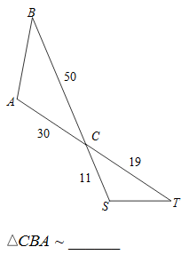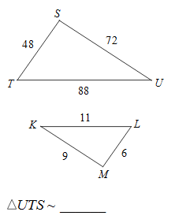

(a) (b)

i. Show work: i. Show work:

ii. Are the triangles similar? _______ ii. Are the triangles similar? _______

iii. **If yes**, then how? _____________ iii. **If yes**, then how? _____________

iv. **If yes**, then complete the similarity iv. **If yes**, then complete the similarity

statement:  statement: 

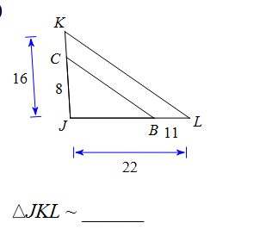 (c)

ii. Are the triangles similar? _______

iii. **If yes**, then how? _______

iv. **If yes**, then complete the similarity

statement: 

i. Show work:

2. The triangles below are similar, solve for x. Work must be shown for full credit.

(a)  x = ________ (b)  x = ________





(c) x = _______



3. Given: , *RS*= 8, *SP*= 12, and *RT*= 4. What is the measure of segment TQ?

[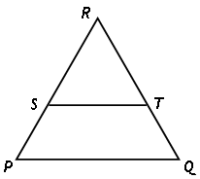](http://www.google.com/url?sa=i&rct=j&q=&esrc=s&source=images&cd=&cad=rja&uact=8&ved=0ahUKEwj4x4CZ0pjNAhUGLyYKHQ52DvoQjRwIBw&url=http://www.winpossible.com/lessons/Geometry_Proportionality_Theorem.aspx&psig=AFQjCNF_37Pp7OnMolUbqERu3VntXaw5XQ&ust=1465481949170937)Show your work to defend your answer:

TQ = _____________