Geometry Name ________________________

Formative Assessment: Similar Triangles Date ______________ Period _____

1. Determine if the two triangles are similar. If so, state the similarity statement and state how

you know they are similar (SSS~, SAS~, AA~). Justify your conclusions. (10 points)

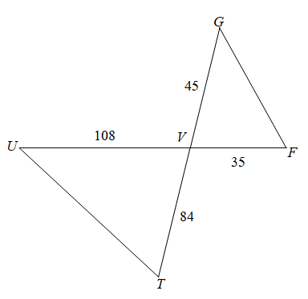

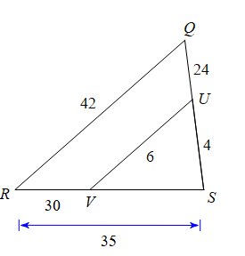 (a) (b)





i. Show work: i. Show work:

ii. Are the triangles similar? _______ ii. Are the triangles similar? _______

iii. **If yes**, then how? _____________ iii. If yes, then how? _____________

iv. **If yes**, then complete the similarity iv. **If yes**, then complete the similarity

statement:  statement: 

2. The triangles below are similar, solve for x. Show work for full credit.

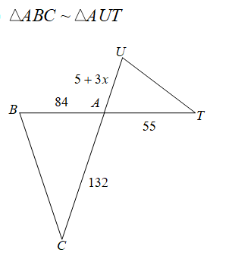 (a) x = __________

(b) x = __________

 