EOC Review Name ________________________________

Units 1-3

1. What are the 4 types of transformations?

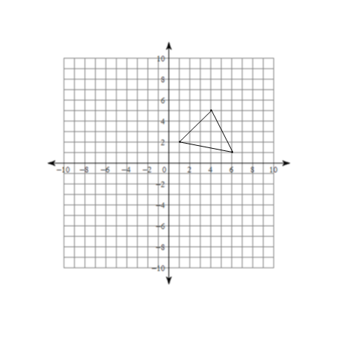

1. Translate the figure using these rules.
2. 
3. 
4. Reflect over the x-axis.
5. (2, -6) _________ B. (0, -5) _________ C. (-4, 3) __________ D. (6, 0) ____________
6. Reflect over the y-axis.
7. (4, 6) __________ B. (-2, -3) __________ C. (0, -4) __________ D. (-5, 0) ___________

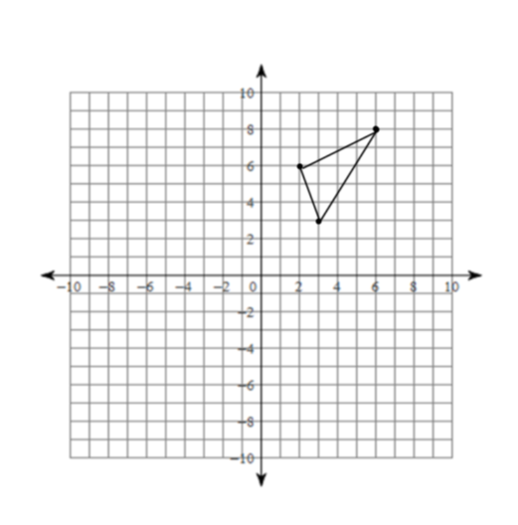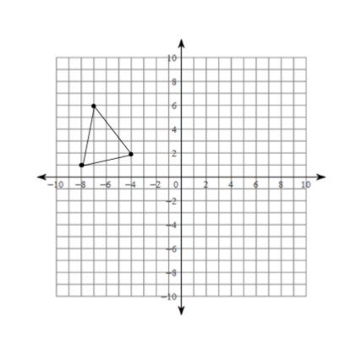

1. Reflect over y = x. 6. Reflect over y = - x



1. Reflect over the line x = - 1. 8. Reflect over the line y = 2.
2. Rotate 90° clockwise.
3. (2, 3) __________ B. (2, -8) __________ C. (-3, 5) __________ D. (-2, -1) ________
4. Rotate 180°.
5. (4, 7) _________ B. (1, -5) __________ C. (-4, -2) __________ D. (-5, -2) _________
6. Rotate 270° clockwise.
7. (3, 9) _________ B. (3, -2) __________ C. (-2, -6) __________ D. (-3, -10) __________
8. Describe the transformation.

1.  ________________________ C.  ____________________
2.  ­­­­­­­­­­­­­­­­­________________________ D.  ______________________

1. Describe the transformation.

1. ________________________ D.  _____________________
2.  ­­­­­­­­­­­­­­­­­_______________________ E.  ______________________
3. _______________________
4. Which transformation(s) result in congruent figures?
5. Which transformation(s) result in similar figures?
6. Describe the result.
7.  ______________________ c.  ______________________
8. 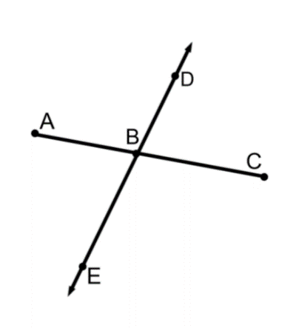 ______________________ d.  ______________________
9. Give an example of each.
10. Line ___________ d. ray ___________

1. Line segment __________ e. acute angle ________
2. Straight angle _________

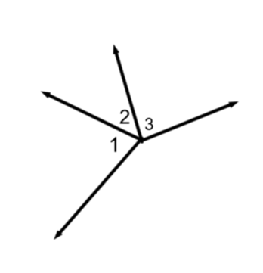

1. Name a pair of adjacent angles. ___________________

Find the value of x.

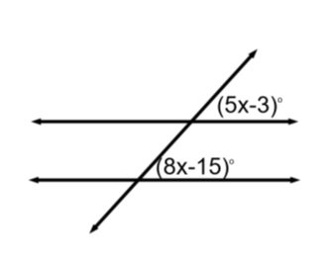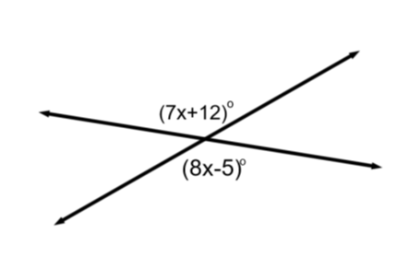

19. 20.

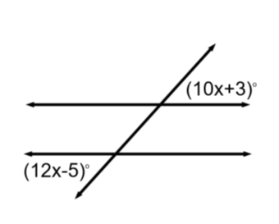

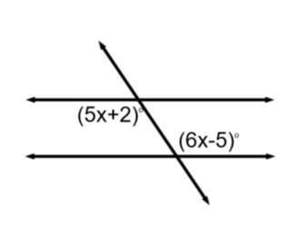

21. 22.

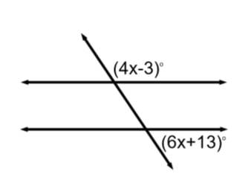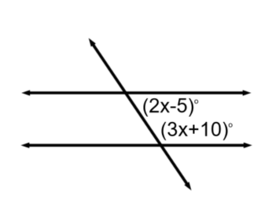

23. 24.

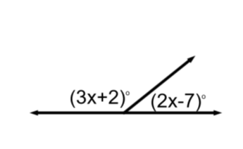

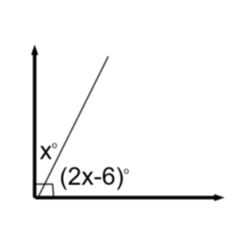

25. 26.

27. Two angles are supplementary. The measure of one angle is three less than twice the measure of the other angle. Find each angle.

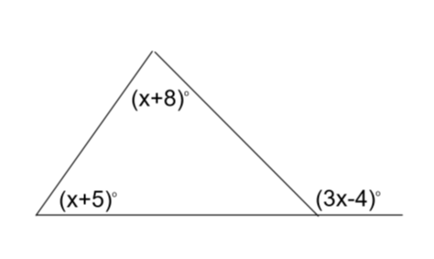Find the value of x.

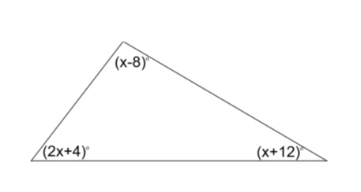

28. 29.

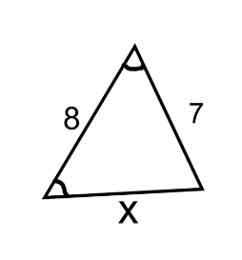30. Solve for x. 31. Solve for x.

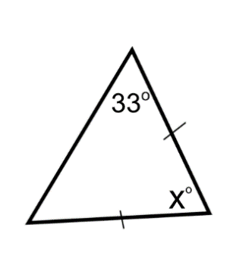

1. 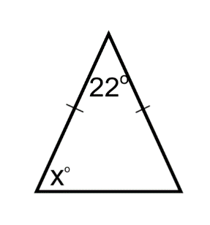 b.

32. Find the center of dilation. 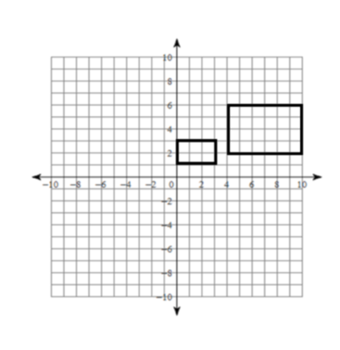33. Are the figures similar?

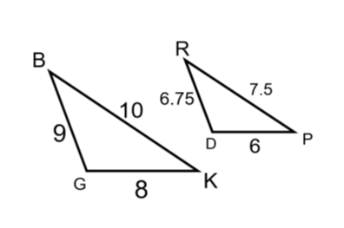

34. What is the scale factor from ? 35. What is the similarity ratio ?



36. Write a similarity statement for the triangles.

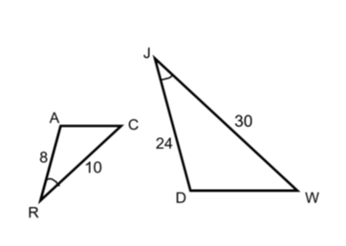

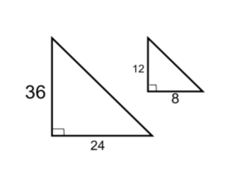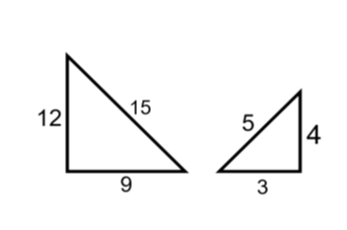37. What is the reason for each pair of similar triangles?

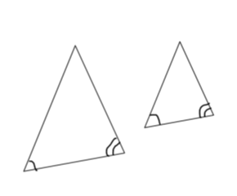

1. b. c.

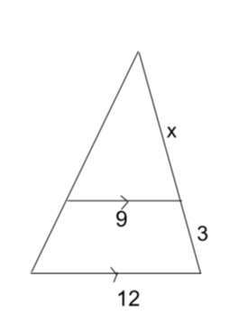38. Solve for x.

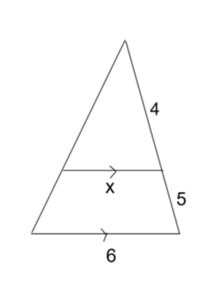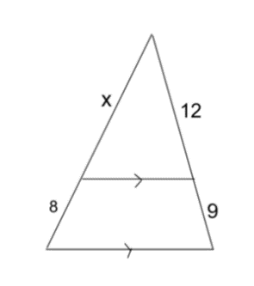

1. b. c.

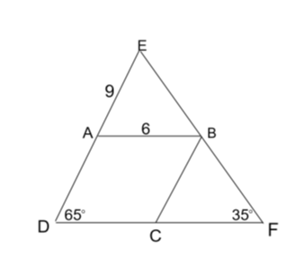

39. A, B, and C are midpoints.

1. What is the name of  ? _________________
2. Solve for each of the following.

AD ________ ED ________ DF _________

CF ________ BC ________ CD ___________

 _________  _________  _________  _________

 _________  _________  _________  _________

40. If A is midpoint, what iscalled? ___________

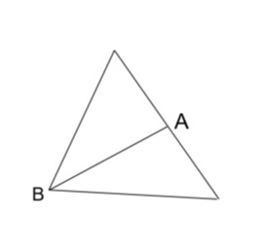

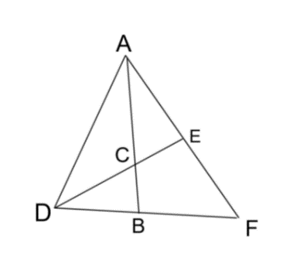

41. B and E are midpoints.

If EC=6, DC=__________ and DE=_______.

If AB=21, AC=_________ and BC=________.

42. How do you know triangles are congruent?

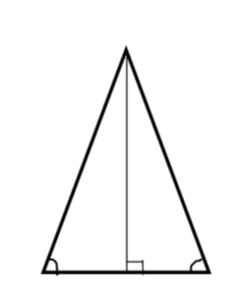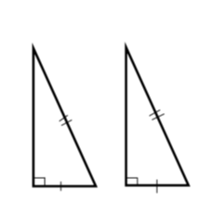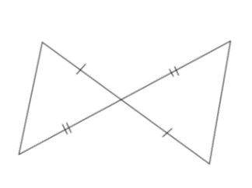43. What is the reason for each pair of congruent triangles?

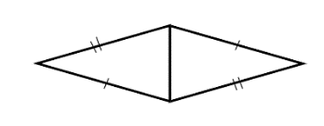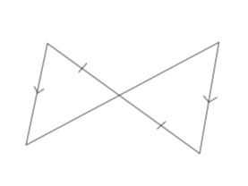a. b. c. d. e. 2 reasons

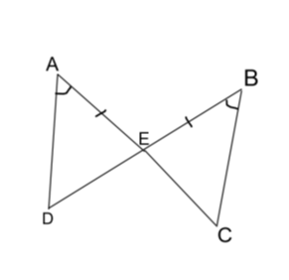44. Write a congruence statement.

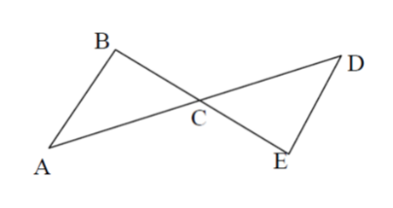45. Complete the proof.

Given: C is the midpoint of  and 

Prove: 

|  |  |
| --- | --- |
| Statements | Reasons |
| 1. | 1. |
| 2. | 2. |
| 3. | 3. |
| 4. | 4. |
| 5. | 5. |

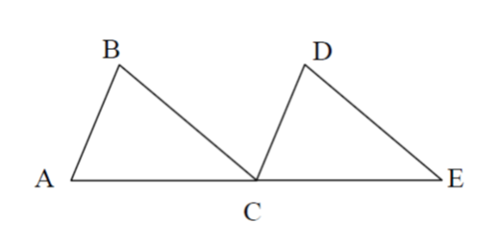46. Complete the proof.

Given: C is the midpoint of  ;  ; 

Prove: 

|  |  |
| --- | --- |
| Statements | Reasons |
| 1. | 1. |
| 2. | 2. |
| 3. | 3. |
| 4. | 4. |
| 5. | 5. |
| 6. | 6. |
| 7. | 7. |



47. Why is  ?

48. What are the 10 most common reasons in triangle proofs?

1.

2.

3.

4.

5.

6.

7.

8.

9.

10.

49. What are the 2 tools used in geometric constructions?

Identify the constructions. (#50-59 mixed up)

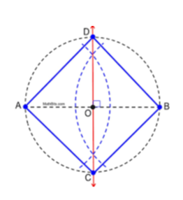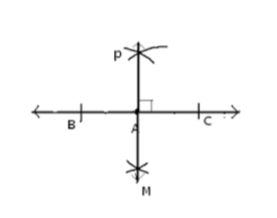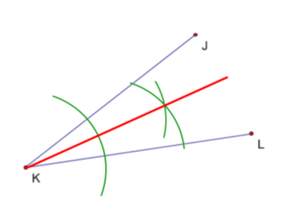50. ______________________ 51. _________________________ 52. _______________________

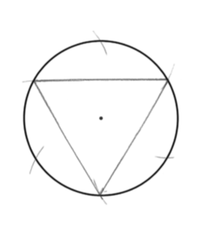53. _____________________ 54. _________________________ 55. _______________________

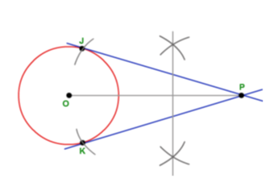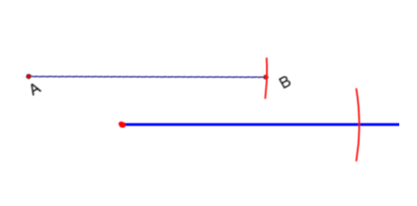

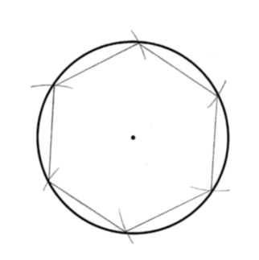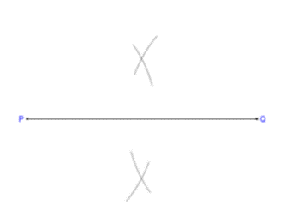56. _____________________ 57. ________________________ 58. ________________________

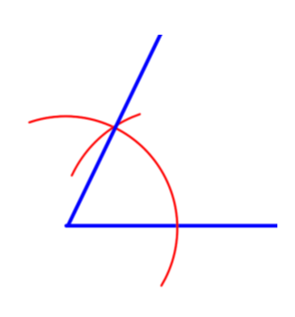

59. ____________________________

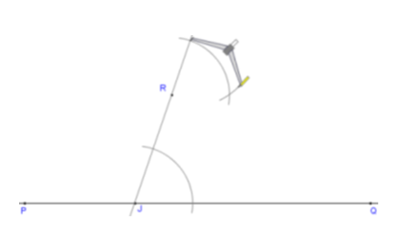

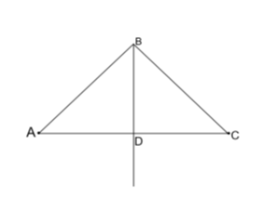60.  is the perpendicular bisector of . If AB=10, what is BC? ____________

61. Write each answer in simplest radical form.

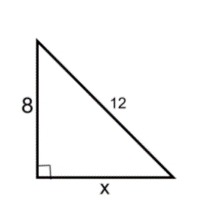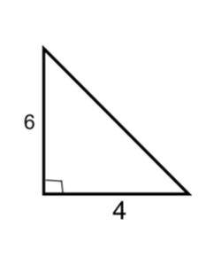 a. Find x. b. Find x.

62. If the perimeter of a square is 28, what is the length of the diagonal?

63. If the diagonal of a square is 18, what is the length of one side?

64. If the perimeter of an equilateral triangle is 24, what is the length of the altitude?

65. If the altitude of an equilateral triangle is 15, what is the length of each side?

66. Find sin A __________ cos A __________ tan A ___________

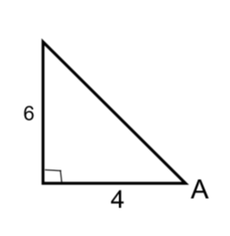

67. Compete each statement.

a. sin 32 = cos ___________ b. If  , find  ___________

c. If , find cos A. _____ d. If  , find cos A. ___________

68. The angle of elevation to the top of a building is 28°. If a person is standing 100 feet from the base of the building, how tall is the building?

69. The angle of depression from a person on top of a building to a car across the street is 18°. If the building is 120 feet tall, how far from the building is the car?

70. Solve for x.

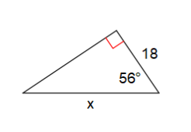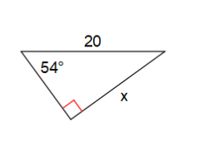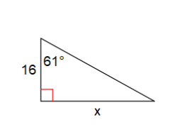 a. b. c.

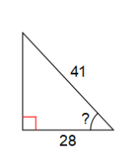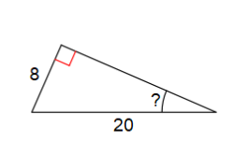71. Solve for x.

1. 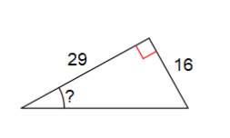 b. c.