Name___________________________________________

Geometry – Unit 3 Right Triangle Trigonometry

**Trigonometric Ratios Study Guide**

**Sine $θ$ = $\frac{opposite}{hypotenuse}$ Cosine $θ$ = $\frac{adjacent}{hypotenuse}$ Tangent $θ$ = $\frac{opposite}{adjacent}$**

1. What does it mean for two angles to be complementary?
2. Find tan34 and find measure of angle A if cosA=0.906307787.
3. Angle $J$ and angle $K$ are complementary angles in a right triangle. The value of $\tan{J}$ is $\frac{15}{8}$. What is the value of $\sin{J}$?
4. Triangle $RST$ is a right triangle with right angle $S$, as shown. What is the area of triangle ?

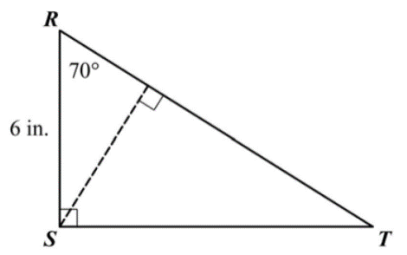

1. 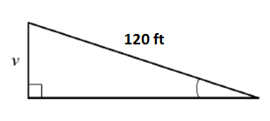A road ascends a hill at an angle of $6°$. For every 120 feet of road, how many feet does the road ascend?
2. Given triangle $ABC$, what is $\sin{A}$?

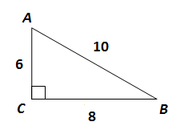

1. In a right triangle, if $\cos{A}=\frac{9}{12}$, what is $\sin{A}$?
2. In right triangle $ABC$, if $A$ and $B$ are the acute angles, and $\sin{B}=\frac{6}{20}$, what is $\cos{A}$?
3. 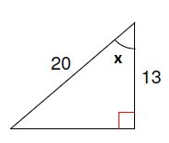Find the measure of angle $x$. Round your answer to the nearest degree.
4. 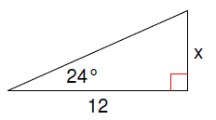Solve for $x$.
5. You are given that $\tan{B}=\frac{19}{11}$. What is the measure of angle $B$?
6. 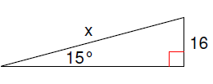Solve for $x$.

1. A ladder is leaning against a house so that the top of the ladder is 18 feet above the ground. The angle with the ground is 47°. How far is the base of the ladder from the house?
2. Given an equilateral triangle has a perimeter of 36 cm, what is the length of its altitude?
3. What is the area of a square with a diagonal of 12 units?
4. Give a right triangle FUN and sin $θ$ =5/12, find sin( $90-θ)$ and cos(90- $θ)$.

**DON’T FORGET YOU NEED TO BE ABLE TO SOLVE FOR A RIGHT TRIANGLE GIVEN 2 SIDES OR GIVEN AN ANGLE AND A SIDE.**

* IF YOU ARE GIVEN **2 SIDES**, USE THE PYTHAGOREAN THEOREM TO FIND THE THIRD SIDE AND THEN INVERSE TRIG RATIOS TO FIND THE ANGLES.
* IF YOU ARE GIVEN **ONE SIDE AND ONE ANGLE**, THEN YOU WILL HAVE TO USE TRIG RATIOS TO FIND ONE OF THE TWO REMAINING SIDES AND THEN YOU CAN USE PYTHAOREAN THEOREM TO FIND THE THRID.

*Look back over old worksheets, Quiz and notes to solve more practice problems!